Project Log

# Week 1.

## Home Page

I started with a two-columns webpage that emulates a traditional CV, in the left side I added a brief description of myself as a professional along with my languages and skills. In the right side I added my work experience and education.

For now I created a header with a greeting and a menu that will take to two other pages.

For CSS I modified my picture to make it round as well as the logos of the companies I have worked. I added temporary colors and backgrounds.

For JS I just added a greeting depending on the hour of the day.

# Week 2.

## Home Page

I added buttons on Skills, when pressing the View More button, the skills are shown in the section. Each Bar represents the percentage of my skill. I added a View Less button to hide again the bars.

I improved some styles in CSS.

## Portafolio Page

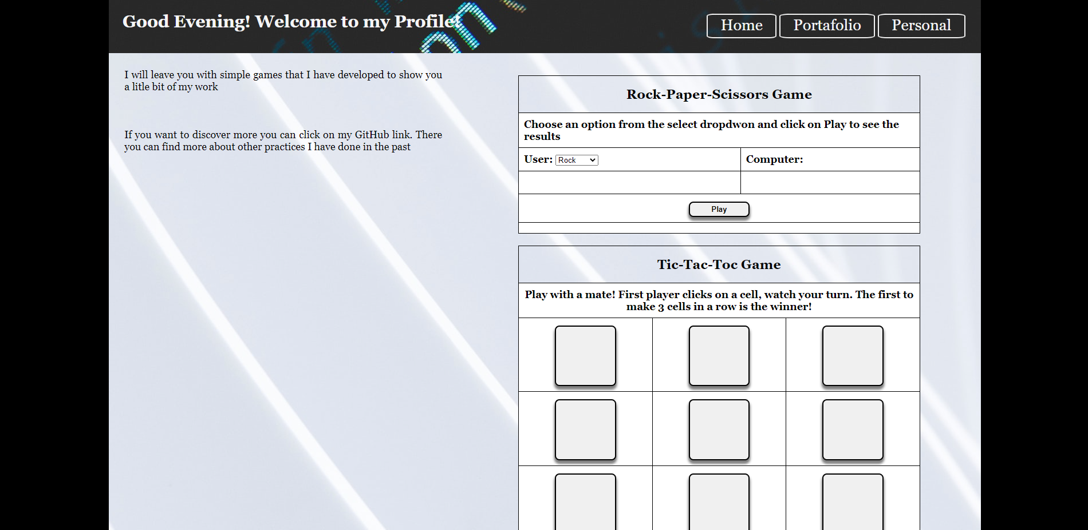

I created a Portafolio page, I used the same styles and header for consistency.

I choose a two-column design as I think that they are enough to show my portafolio

In the left side I will add hyperlinks to Linkedin and Github (I haven’t implemented yet)

In the right side I wanted to add a couple of games:

* I created a rock, scissors, paper game using and improving an old class exercise, I use a table to organise the items of the game, for the logic I used basic JS
* I created a Tic Tac Toc game for two player, I used buttons in a table to represent the game board, for the logic I used basic JS